Medien Homepage: 1-8

[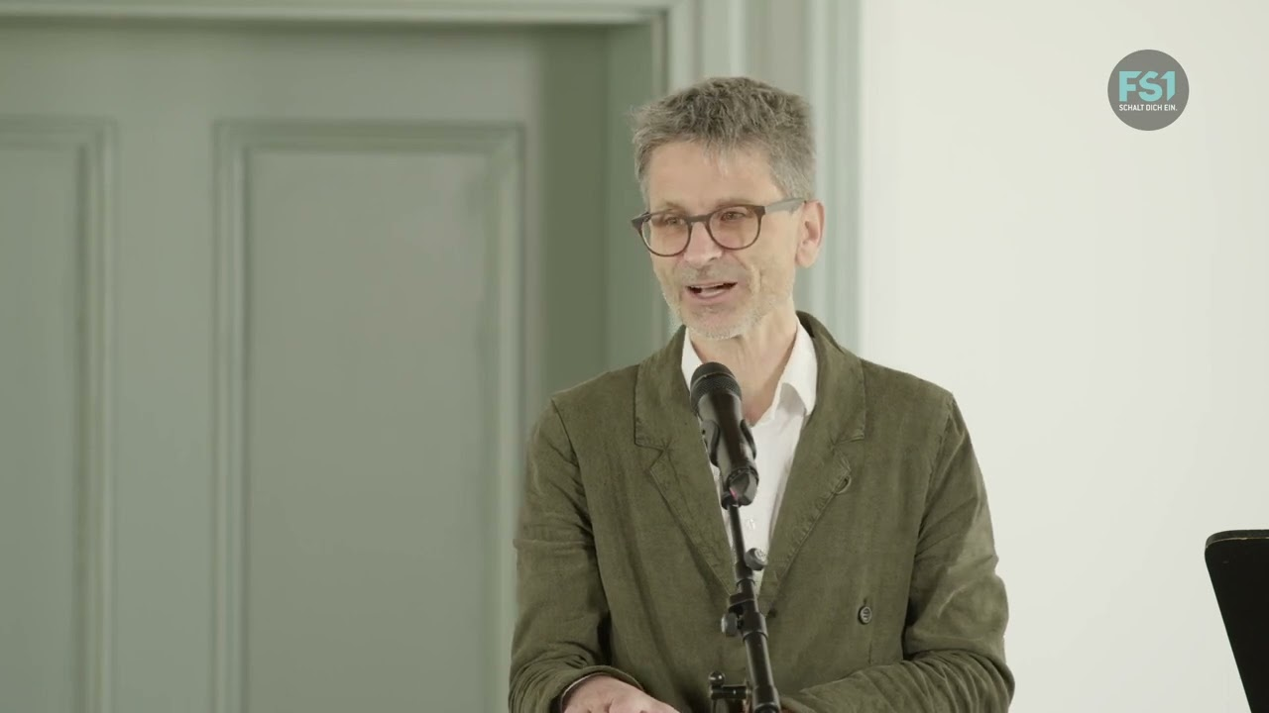](https://www.youtube.com/watch?v=3I5-dAJ3cI0)

Ab1:41:44 ca….da wo das Glockenspiel startet

<https://www.unitv.org/beitrag.asp?ID=299#>

His holy ping pong Markus Sepperer/Irmgard Messin

<https://static1.squarespace.com/static/57e11572579fb32aef3141e7/65eb6e8389b2604f49406a99/65eb6edb272b32549a7d2eb9/1709928332779/His+Holy+Lama+Ping+Pong.mp3>

Irmgard Messin Solo CD flute

https://www.hevhetia.com/product/flute/

[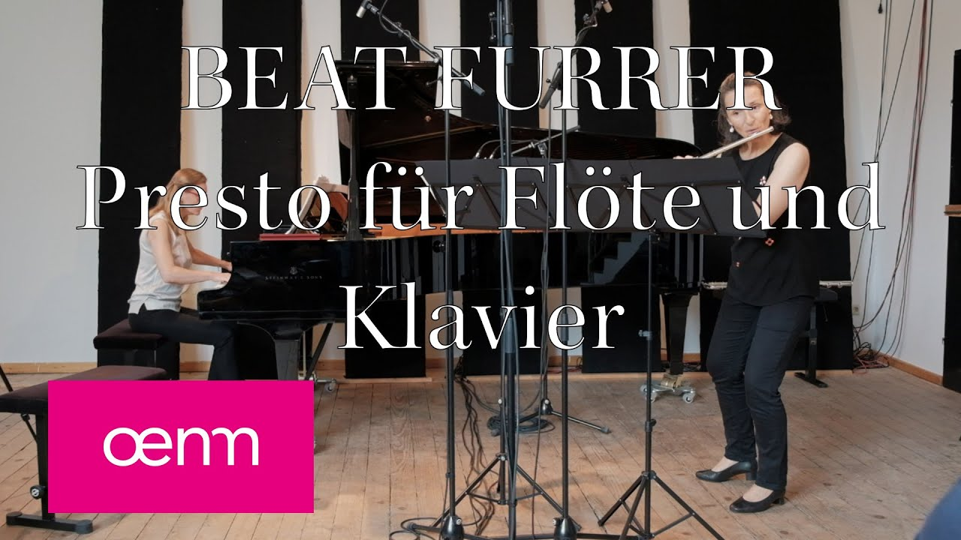](https://www.youtube.com/watch?v=-nvxLgaILS8)[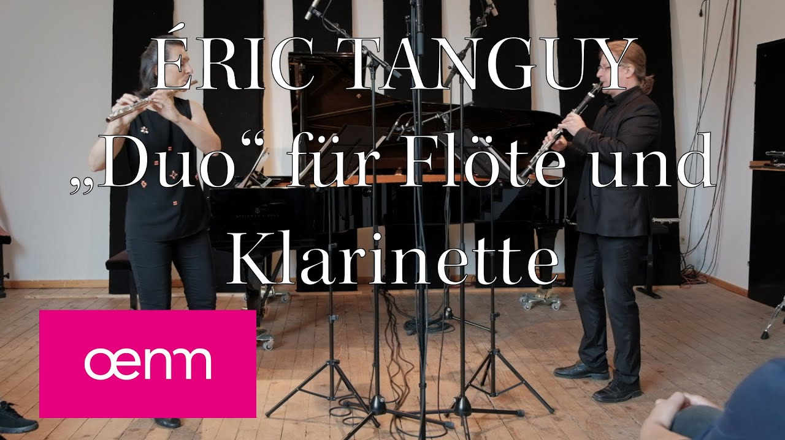](https://www.youtube.com/watch?v=Vuu22XFUN0o)

<https://www.unitv.org/beitrag.asp?ID=299&Kat=1&SubKat=16> das 5.Video[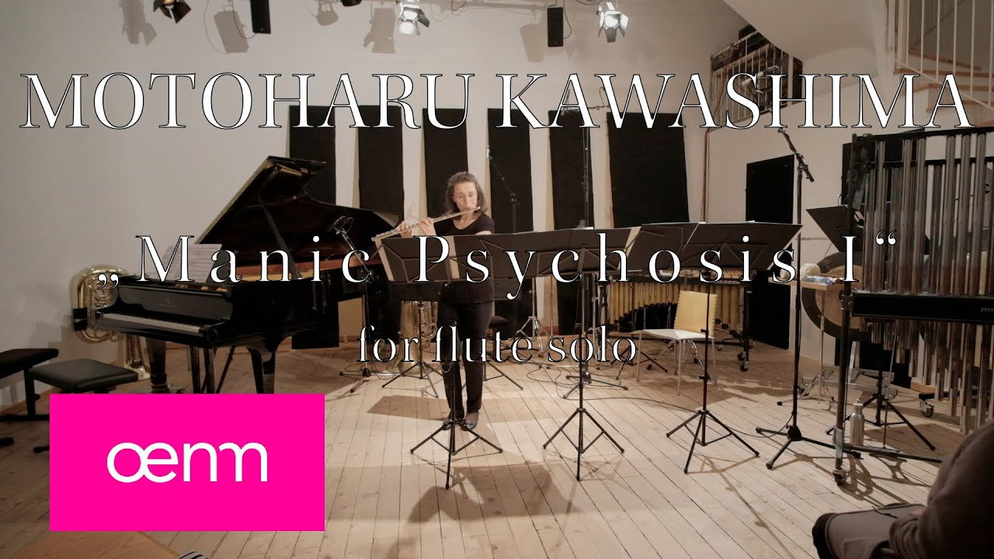](https://www.youtube.com/watch?v=BX8kGveJgwU)[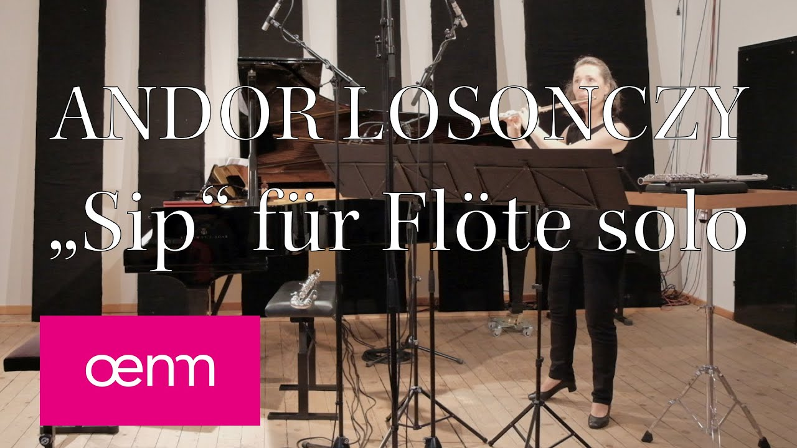](https://www.youtube.com/watch?v=ovyzHHRSNtA)